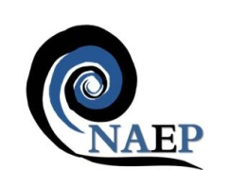
National Association of Educators in Practice

Annual Conference
Friday 20th April 2018
The Studio, 7 Cannon Street
Birmingham, B2 5EP
Cost: ONLY £90.00
(pre-registration students: £50.00)

Learning in Practice: a critical perspective

Investment in the future of the health and social care workforce is everybody’s business, but is not without its challenges, particularly in the current context of scarce resources. An increased emphasis on values, quality and productivity requires us to work together to find new solutions, optimising capacity by sharing innovation and building on what works well. The contribution of practice based learning to this agenda is significant and provides the focus for the 2018 conference.
Conference Themes

- Values-based learning in practice
- Quality improvement in and through practice learning
- Enhancing capacity and productivity in and through practice learning

Confirmed speakers include:
Jenny Miller, Chief Executive of PAMIS (Promoting a More Inclusive Society), based in Scotland with the Head office within the University Of Dundee campus, they are the only UK charity that works solely with people with profound and multiple learning disabilities and their families. Jenny also led at NHS Education for Scotland for the first interprofessional Scottish Health and Social Care Team Challenge (SHSCTC).

Call for papers and posters can be found at:
naep-uk.org/conference
Register for the conference at:
Eventbrite: NAEP conference 2018

