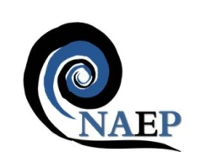
National Association of Educators in Practice

Annual Conference
Friday 24th April 2020
The Studio, 7 Cannon Street
Birmingham, B2 5EP

Cost: £98.00
(pre-registration students: £50.00)

Whose placement is it anyway?

Effective practice-based learning depends on learners, practice educators, academic tutors, service managers and employers working collaboratively, with the shared vision of enabling the future workforce to meet the evolving needs of the people who use our services. It can be challenging, however, to balance the needs of all those involved in or affected by practice education. This year’s conference aims to bring together different perspectives on the practice learning experience, and to share good practice in balancing some of the tensions in practice education arising from:

- Diversification of practice
- Diverse learners and service users
- Capacity and recruitment: service needs
- Expectations and experiences of new generation learners
- Service user expectations and expertise
- New models of learning

We welcome submissions for platform presentations (15 minutes max) or posters addressing any of the issues or themes above, with a focus on implications for practice-based learning. Topics might include:

- New/emerging roles and practice education
- Preparing learners for portfolio careers
- Practice learning in diverse contexts and settings
- Promoting diversity and inclusion in the workforce
- Supporting learners with varying learning needs
- Becoming ethical practitioners
- Ensuring a representative and diverse workforce
- Partnership working between placement and education providers
- Promoting a practice learning culture within teams/services
- Beyond RePAIR
- Learners’ contribution to productivity and service improvement
- Service user involvement in practice learning
- Personalised care: implications for practice learning
- Learners’ perceptions of placement experience
- Digital technologies in practice based learning
- Mixing generations and learning from each other
- Apprenticeships and workplace learning
- Distance learning in practice
- Interprofessional learning in practice

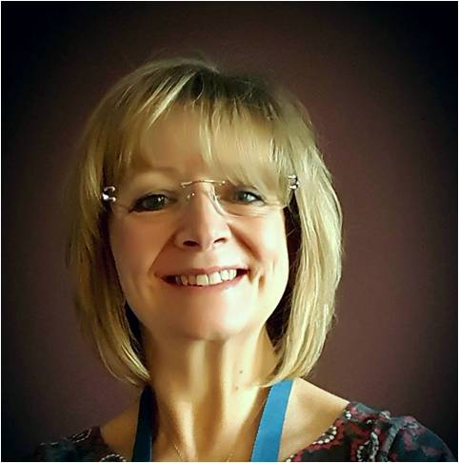
Keynote speaker: Dr Leslie Robinson EdD, MSc, DCR

Presentation Title: Changing places: educating for patient and public partnerships

Leslie trained as a Diagnostic Radiographer at Bradford in 1980-83. She worked for 16 years in clinical practice in Leeds, Bradford, Saudi Arabia, Birmingham, Manchester specialising in CT and MRI. In 1999 she moved into academia becoming a full time lecturer at the University of Salford. During her time at Salford she was programme leader for undergraduate and post-graduate programmes and she also completed a Doctorate of Education.

Leslie retired from her full time post in March 2018 but retains links with the university as an Honorary Reader, and she also has an Honorary Associate Professor contract with Swansea Medical School. Her current research interests focus on exploring patient, public and practitioner partnerships for improving the quality of healthcare.

In 2018 she was commissioned by the College of Radiographers to lead a small task and finish group whose remit was to develop a plan for promoting Patient, Public and Practitioner Partnerships within radiography practice. The outcome from this project is the 4P document which has been presented nationally and internationally (Vienna and Chicago) as an example of innovative person-centred practice.

Call for papers: | naep-uk.org/conference
Register at: | Eventbrite: NAEP conference 2020

